**Assignment 3**

**Due**: November 30, 2023

1. You work at an advertising agency and have been asked to assess a recent six-week ad campaign for a client. The data you are focusing on is incremental reach, which you measure “per 1,000 impressions.” You have a colleague who did a similar analysis for a different client recently, so rather than start from scratch, you’ve updated her visuals with your data as a starting point. Next, you want to edit and refine.

Figure 1 shows the visual you’ve created. Spend a couple of minutes to familiarize yourself with the details, then complete the following.

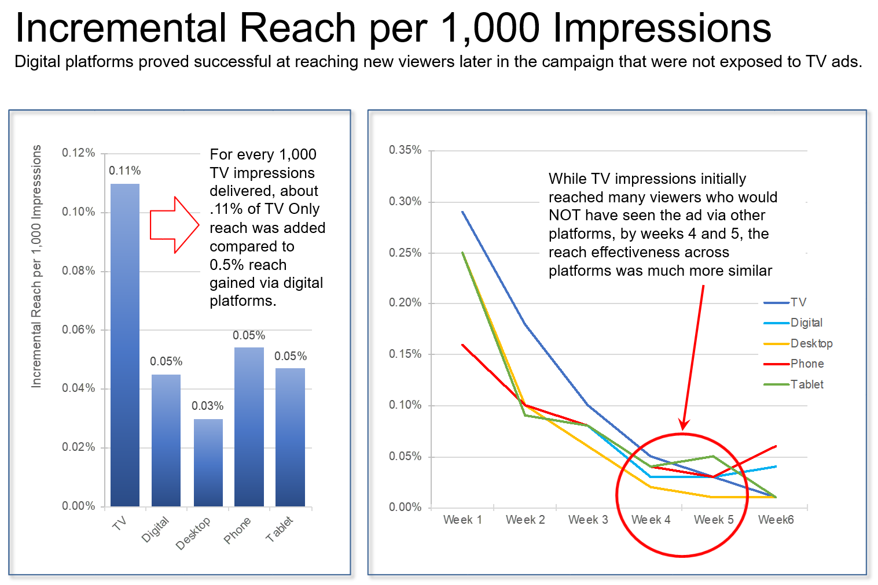

**Figure 1**

1. What is working well. What do you like about the current view of the data?
2. A number of steps have been taken in Figure 1 to direct attention and help explain. Which are working well? Where and how might you adjust?
3. What clutter would you eliminate? What elements would you push to the  
   background?
4. What other design choices made here do you question given the lessons  
   in class? What additional changes would you make?
5. Use the data in file *Problem_1.xlsx* and current graphs. Refine the visual by making the changes you’ve outlined in the steps above using the tool of your choice.
6. Imagine you work for an on-demand printing company. An interesting topic for the company is the competitive landscape for your products. As part of this area of focus, your colleague has been asked to pull together some data on your main competitors’ market share over time. He comes to you with his slide—Figure 2—and asks for feedback.

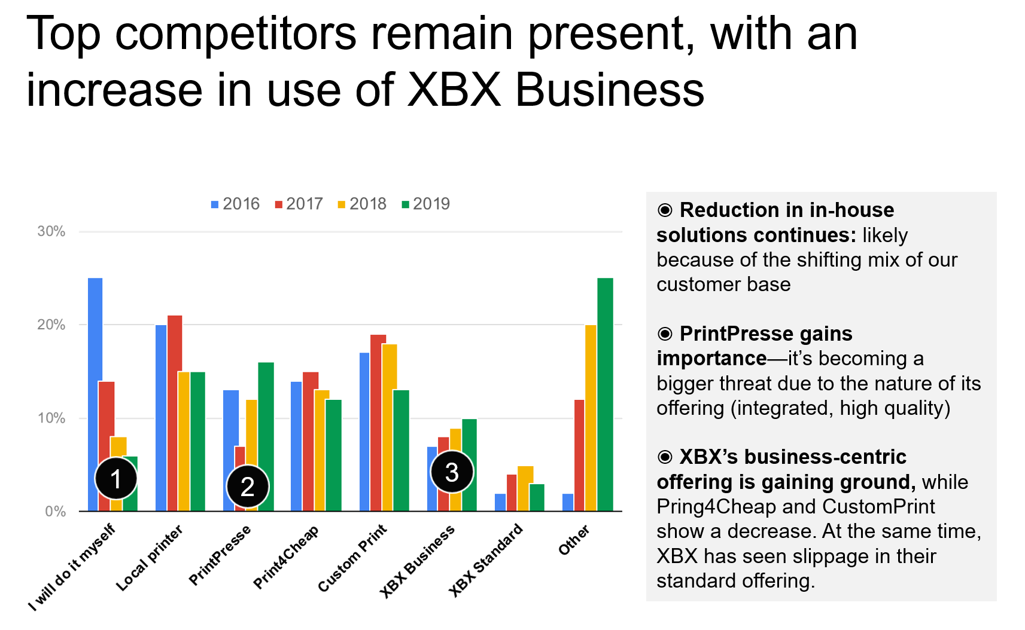

**Figure 2**

1. List 5 design improvements you would recommend making to this slide. Articulate not only what, but also why. How specifically will your ideas improve the design?
2. Use the data in file *problem_2.xlsx* and execute the changes you’ve outlined in the tool of your choice.
3. Consider how you would present this material in a live meeting compared to something that has to be sent around as a stand-alone document. How would your approach change between these two instances? Write a few sentences to explain.